Task 001

Exception – out of boundary exception

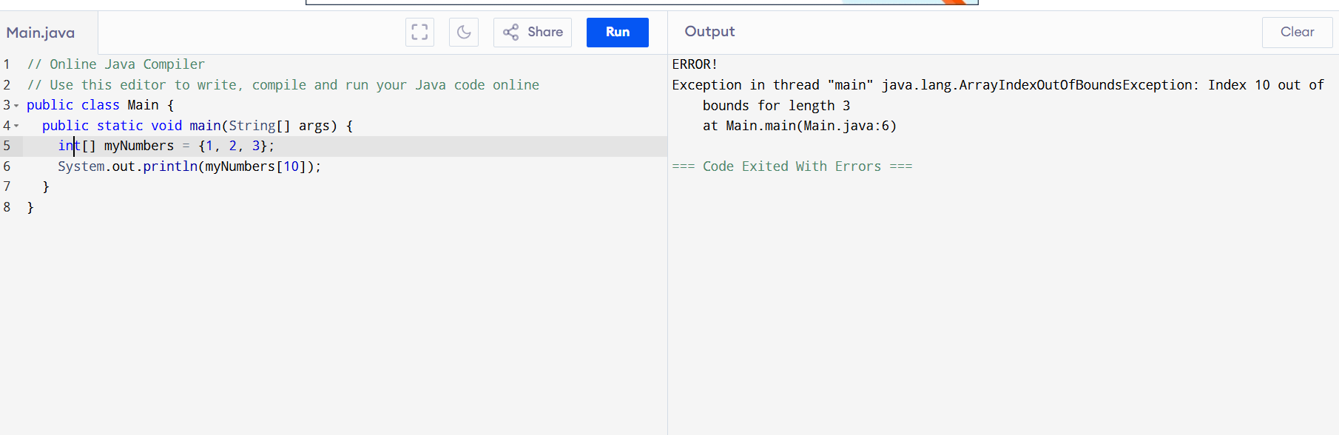

Task 002

Using try block

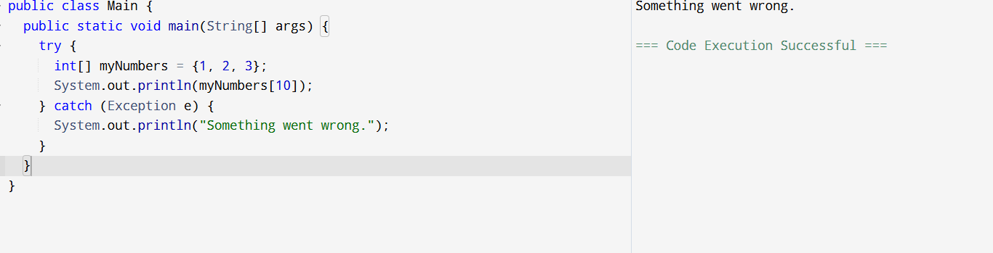

Task 003

Using finally block

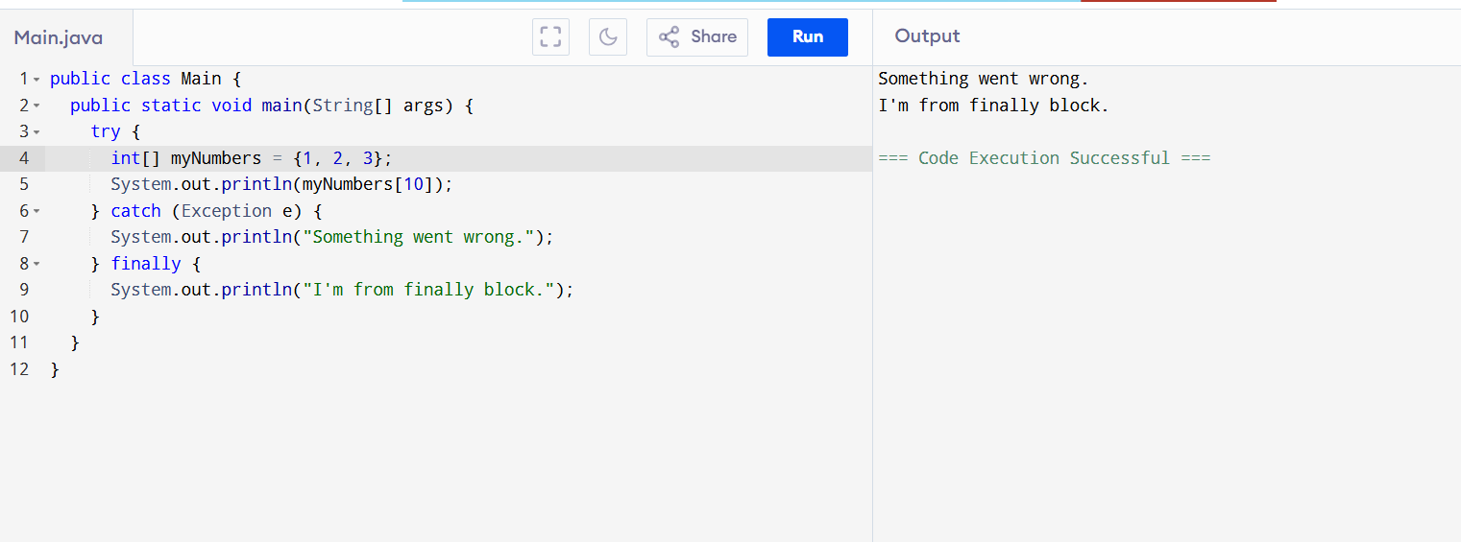

Task 004

try accessing index 4

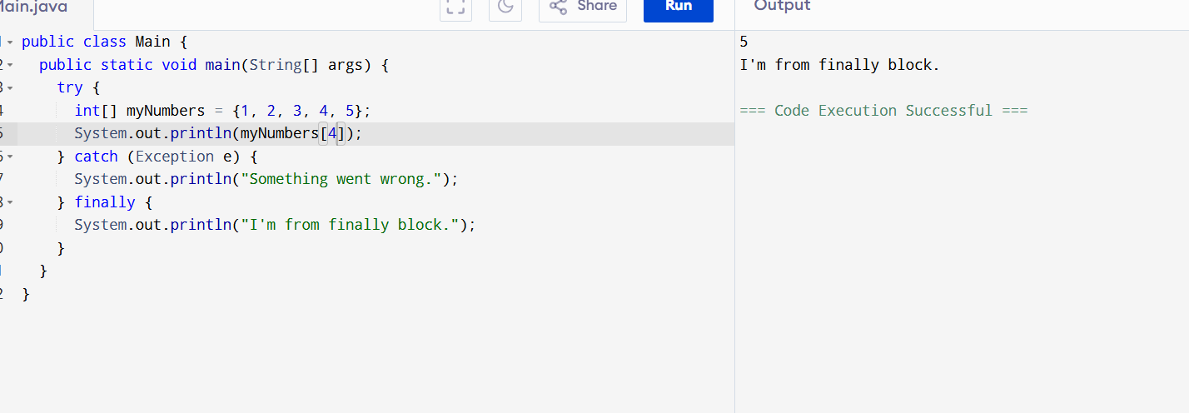

Task 005

Multiple catch blocks

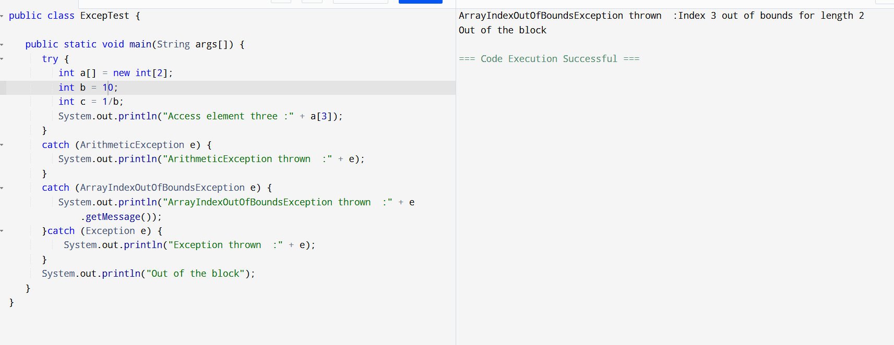

Task 06

Using nested loops

Using multiple try

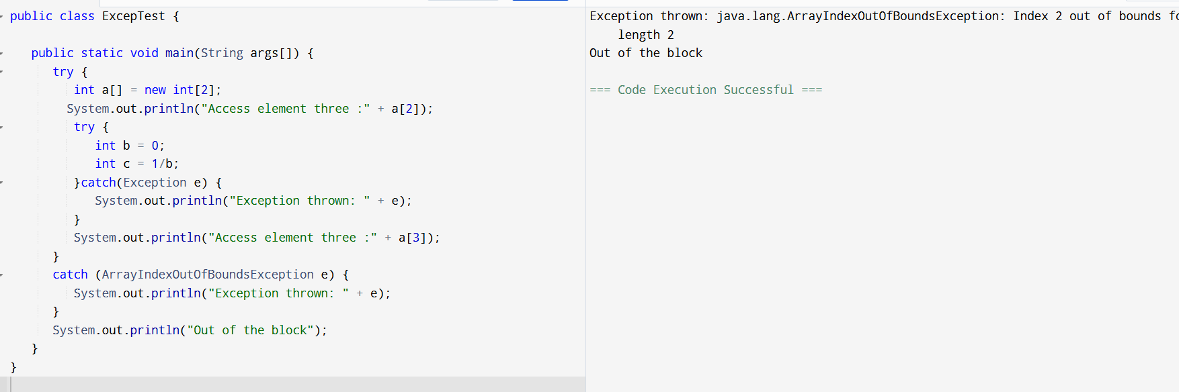

Task 07

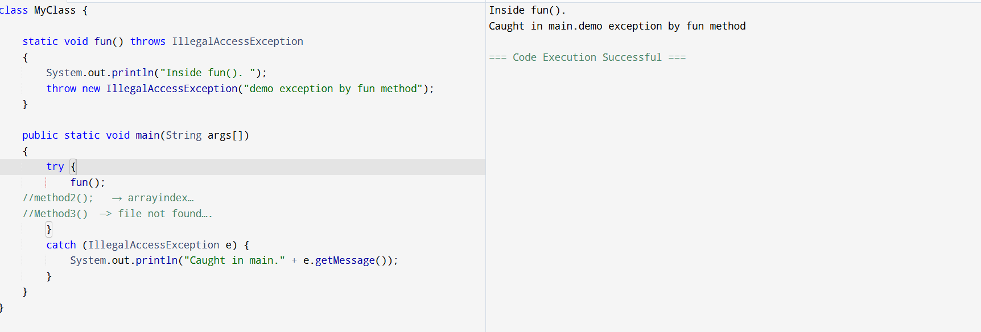

Task08 custom exception

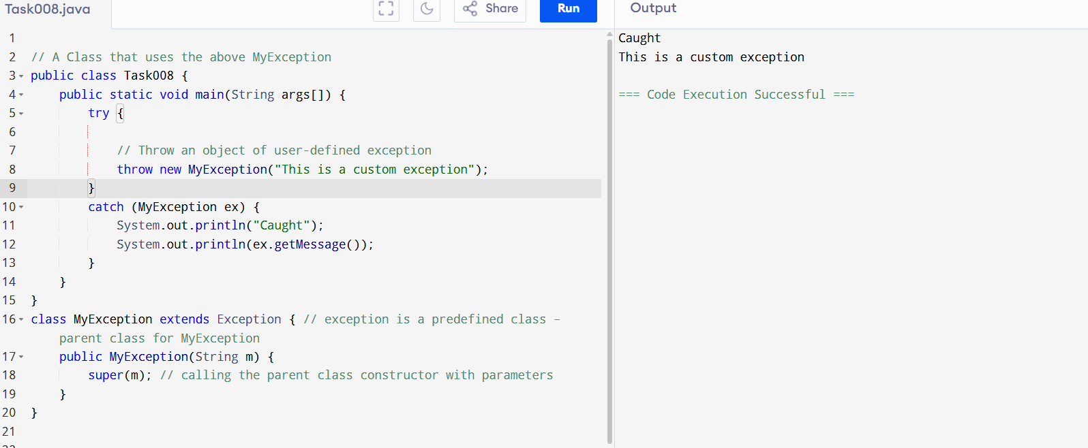

Task 09

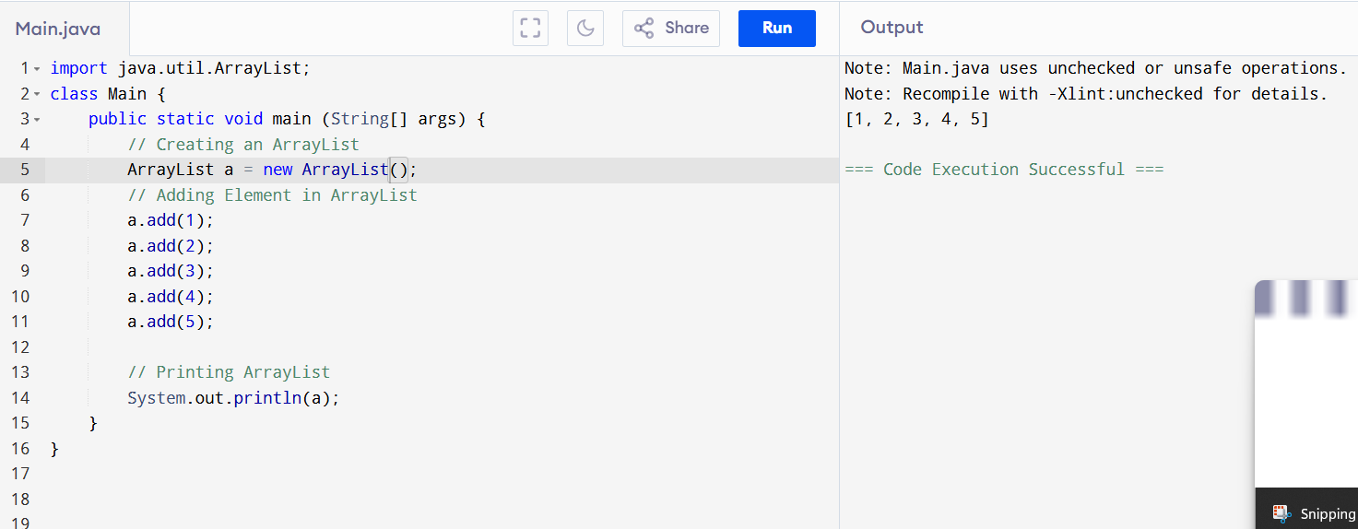

Task010

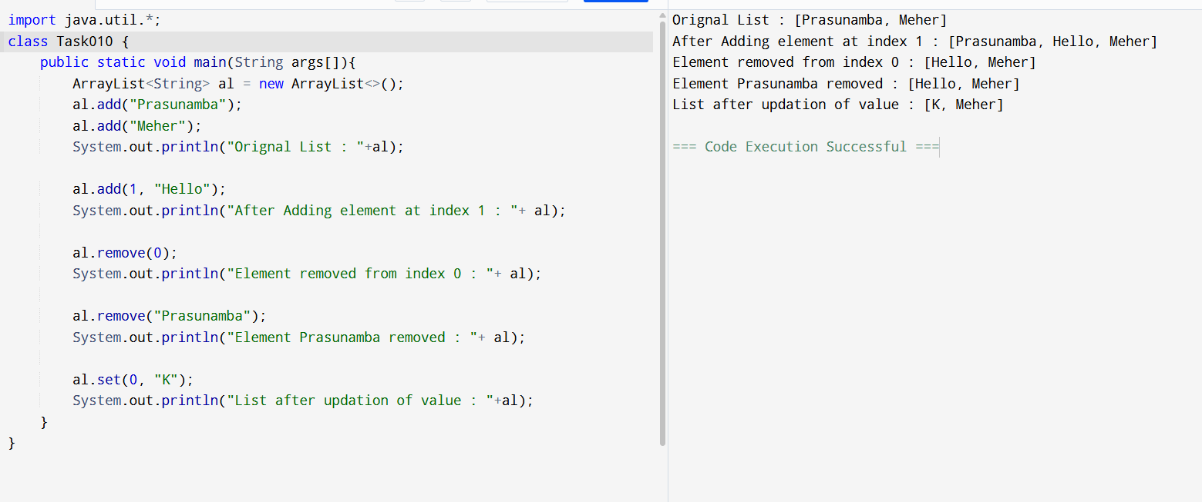

Task 012

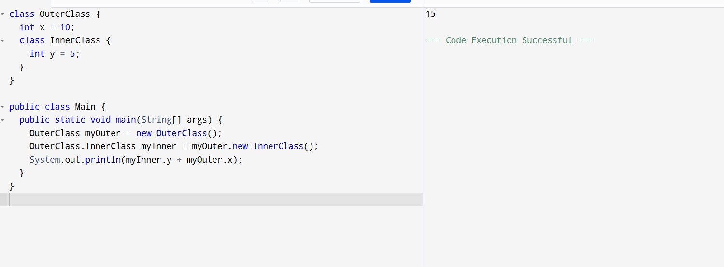

Task 13

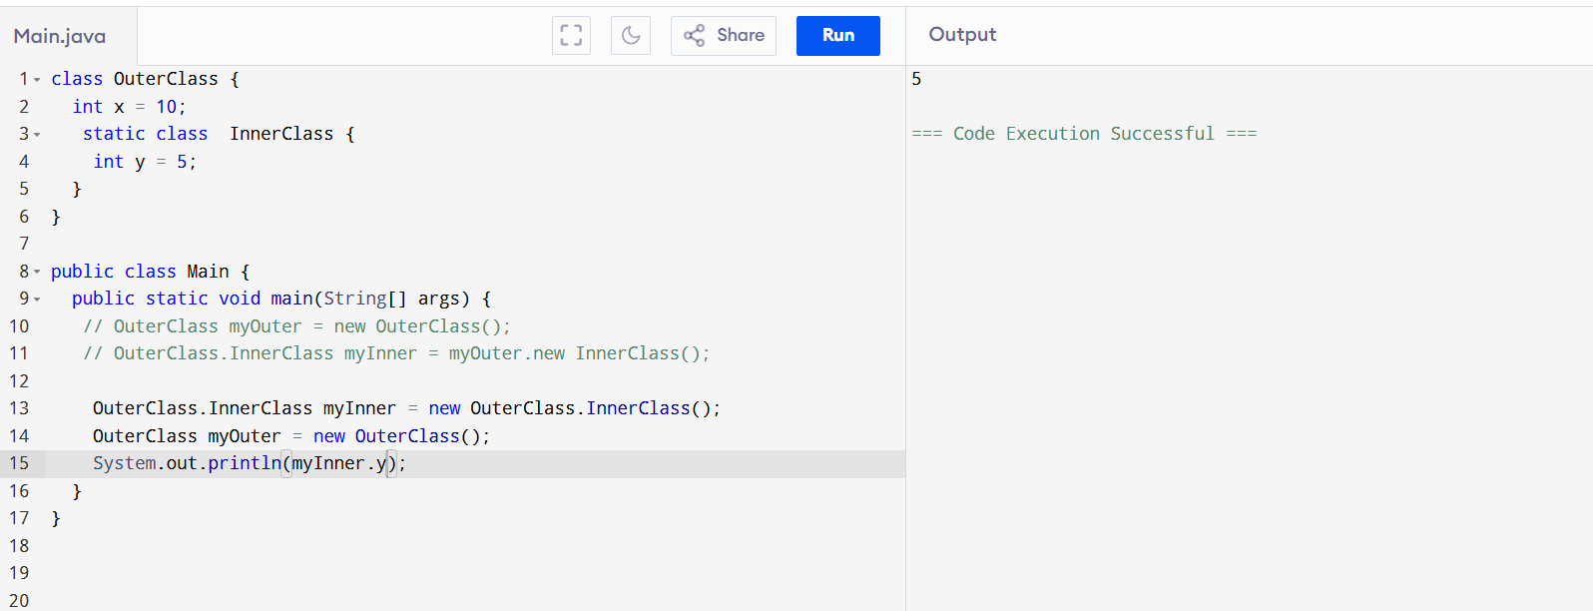

Task 14

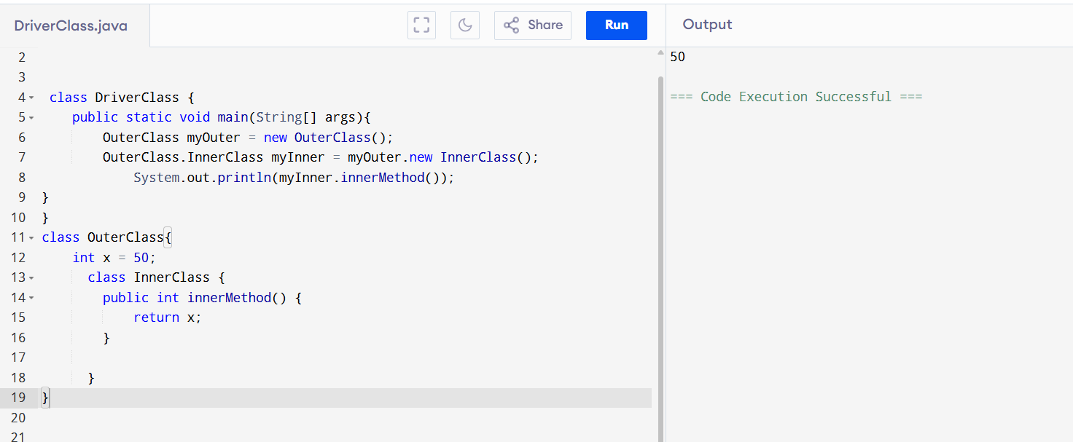

Task 15

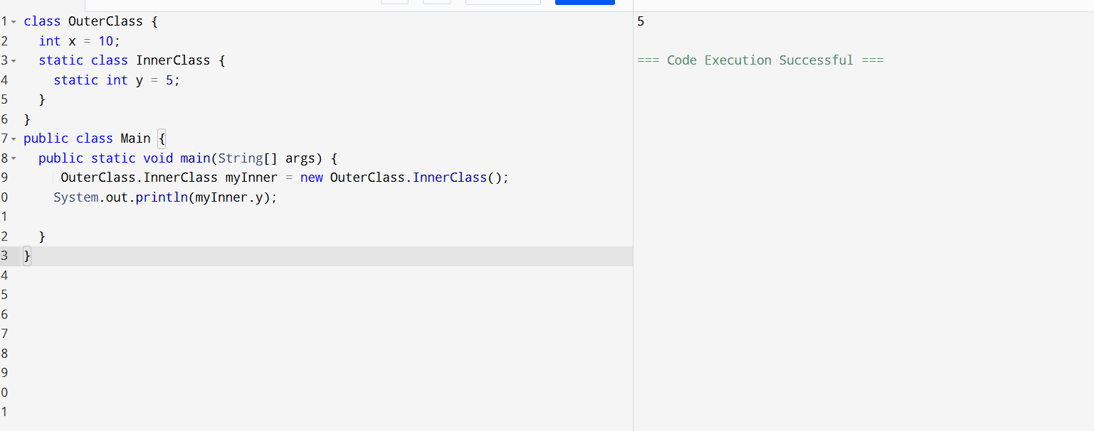

Task features of java8

**Java 8 Features**

Lambda Expressions

Functional Interfaces

Introduced and Improved APIs

Stream API

Date/Time API

Collection API Improvement

Concurrency API Improvements

Optional Class

forEach() Method in Iterable Interface

Evolve interfaces without breaking compatibility.

Static Methods

Method Reference

Task 19

